Employee Management & Analytics Dashboard – UI/UX Case Study
Designed by: Raju Kattepogu
1. Project Overview
The Employee Management & Analytics Dashboard was designed to help organizations visualize workforce data, performance metrics, and project analytics in a single, structured interface. The dashboard focuses on clarity, readability, and actionable insights for HR teams, managers, and leadership.
The visual direction emphasizes a modern, minimal, and highly organized layout that supports quick decision-making.

2. Problem Statement
Most existing HR dashboards struggle with:
- Overcrowded layouts
- Poor data hierarchy
- Confusing graph structures
- Inconsistent UI components
- Difficulty identifying trends quickly
The challenge was to create a dashboard that simplifies complex data, reduces cognitive load, and presents insights clearly.
The objective was to design a system that enables leadership to view organizational health at a glance.

3. Design Goals
1. Create a clean and structured interface
Focus on visual spacing, alignment, and clarity.
2. Present analytics in a simple and digestible format
Use clean charts, well-spaced cards, and standardized color logic.
3. Improve navigation and efficiency
Introduce a left-side navigation bar with main sections such as Dashboard, Employee, Performance, and Reports.
4. Ensure UI consistency
Build a unified system for cards, filters, icons, and data components.

4. Target Users
The dashboard is designed for:
- HR Managers
- Team Leads
- Senior Leadership
- Project Managers
- Workforce & Planning Analysts
User expectations include:
- Quick interpretation of key metrics
- Clear comparison of employee performance
- Minimal and modern visuals
- Role-based and date-based filtering
- Efficient navigation with low friction

5. Design Process
1. Research
Reference dashboards analyzed:
- BambooHR
- Zoho People
- Microsoft Power BI
- Tableau HR Dashboards
Key insights:
- Dashboards should avoid visual noise
- Growth indicators should be subtle but visible
- Neutral color palettes improve readability
- Data hierarchy is essential for clarity
2. Wireframing
Low-fidelity wireframes were created to define:
- Employee summary section
- Team insights
- Performance charts
- Project analytics area
- Navigation and page structure
Wireframes ensured logical information flow and minimal navigation steps.
3. Visual Design
The visual system incorporates:
- Soft grey backgrounds
- White cards with smooth elevation
- Muted greens for positive metrics
- Clean sans-serif typography
- Balanced spacing for clarity

6. Final Dashboard Sections
1. Employee Summary Cards
Includes Total Employees, New Employees, and Performer Employees.
Each card contains growth indicators to help users understand progress quickly.
2. Team Insights
Shows total employee count and distribution across departments such as Development, Design, Testing, and Sales.
A supplementary bar chart highlights team-based growth since the previous quarter.
3. Average Team Contribution
A semi-circular gauge showcasing Total Score and Last Month’s Score.
Helps measure team engagement and contribution levels.
4. Team Performance Analytics
A stacked bar chart representing monthly performance from July 2023 to June 2024.
Designed to help compare and analyze role-based contributions.
5. Project Analytics
A comparative bar chart tracking Development and Design performance on a monthly basis.
Useful for monitoring workload and productivity patterns.
6. Project Overview Cards
Includes Total Projects, Completed Projects, Ongoing Projects, and Cancelled Projects.
Each card uses subtle color cues for quick identification.

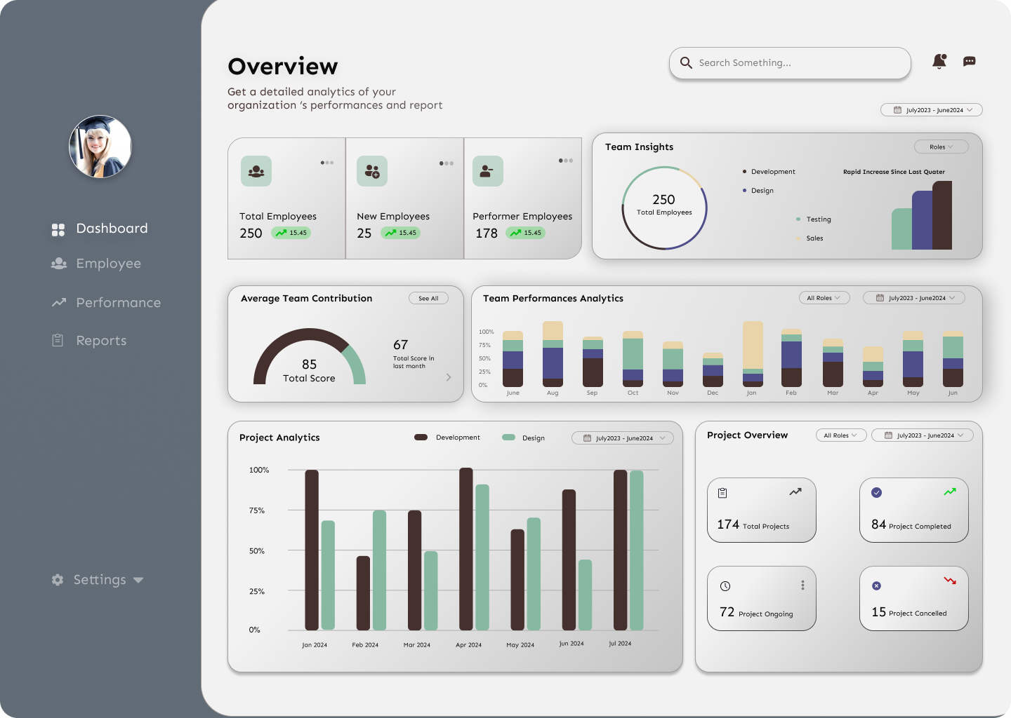

7. Key Features Designed
- Clear and structured data visualization
- Date and role-based filtering
- Team contribution breakdown
- Modern UI components
- Sidebar navigation for simple workflow
- Growth indicators and trend metrics
- Minimal and readable chart system
8. Design System Summary
Color Palette
- Neutral greys and whites
- Muted greens for positive metrics
- Soft, subdued chart colors
Typography
Modern, clean sans-serif font with strong readability.
Components
- Rounded card layout
- Consistent spacing scale
- Simplified iconography
- Clean chart legends and labels

9. Tools Used
- Figma (UI Design & Prototyping)
- Illustrator / Photoshop (Asset refinement)
- Freepik / Unsplash (Profile images and assets)

10. Learnings & Improvements
Learnings
- Dashboard clarity improves when unnecessary colors are removed
- A card-based layout helps users scan information quickly
- Performance analytics need structured comparison models
- Filters significantly enhance usability for management teams
Future Enhancements
- Add employee profile pages
- Introduce AI-driven performance insights
- Enhance project-level forecasting
- Include dark mode
- Add real-time alerts and notifications

11. Figma Prototype Link
Employee Analytics Dashboard Design
https://www.figma.com/design/kb7jNFAnf6ZYAYSfImSJv4/Untitled?node-id=1-5&t=XTrcjEYBqVh6HUtD-1

12. Conclusion
The Employee Analytics Dashboard provides:
- A clean and visually structured interface
- Accurate organizational insights
- A simplified way to monitor team and project performance
- A modern experience designed for real business usage
This project demonstrates the ability to transform raw data into a professional, user-friendly analytics system suitable for growing organizations.

Raju Kattepogu – Future Interns UI/UX Task 2

